|  |  |  |  |  |  |
| --- | --- | --- | --- | --- | --- |
| Date | 10-Dec-22 | | | Tester Name | Mohammad Yusuf |
| Environment | Penfax - Test | | | Login used |  |
| Operating System | Windows | Version: | Update: | | |
| Software Used | Select Software | Version: | Update: | | |
| Select Software | Version: | Update: | | |
| Release version |  | | | | |
| Title |  | | | | |
| Test Type | Regression | | | | |
| Test Scenario |  | | | | |
|  |  | | | | |
| Expected Results |  | | | | |
| Pass/Fail | Select | | | JIRA# | N/A |

Describe your steps with screenshots:

|  |
| --- |
| in PENFAX5 do a search for the member Click on the Stakeholder ID |
| Click on Payment Instructions Click Add Under Payee type Select Alternate Click on the magnifying glass by Payee Stakeholder.  Click on organization and search for the employer the member works for Hit Save |
| Click on Tax Instructions Click Add Click Save |
| Click on Investments Under Account Instructions Click +Add |
| Under Instruction type select Lump Sum Withdrawal Keep effective date the same Under Lump Sum Withdrawal Type select Maintenance Order Under Lump Sum Withdrawal Method select Gross Amount Enter a gross amount $1500 Click the add button by fund  Select a fund from the dropdown Select a Contribution type from the dropdown, Employee required. Enter a gross amount of $750 Click Add again. Select a fund, And select contribution type Employer required. Fill in the $750 gross amount Make sure the Fee Applies box is checked Click Save |
| Wait for overnight batch processes to run |
| Go to the Communcaitons Tab Make sure under outbound documents there is a confirmation of payment letter |
| Go to Tax slips.  Make sure there are no tax slips for this payment |
| Go to the Investment Tab.  Do a search under Account Activity.  Make sure the transcation you posted of $750 gross is listed per source |
| Go to Member Profile.  Membership status should still be Active |
| Click on Accounting then on General ledger Under Plan select PEPP Under Account Select 02-51120-00 Maintenance Enforcement.  Click Search |
|  |

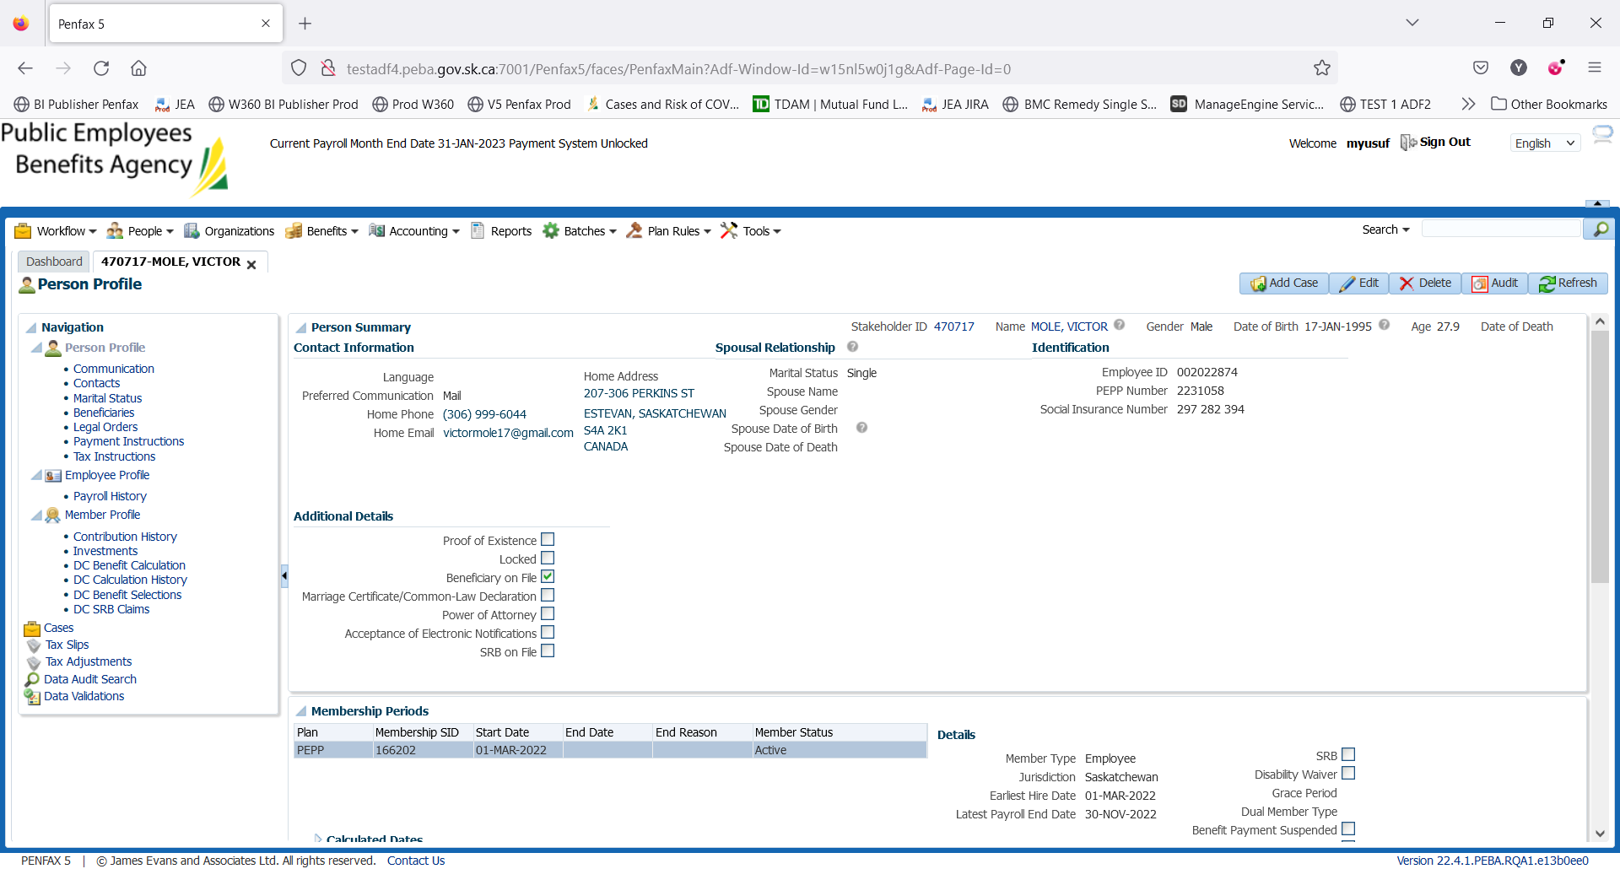

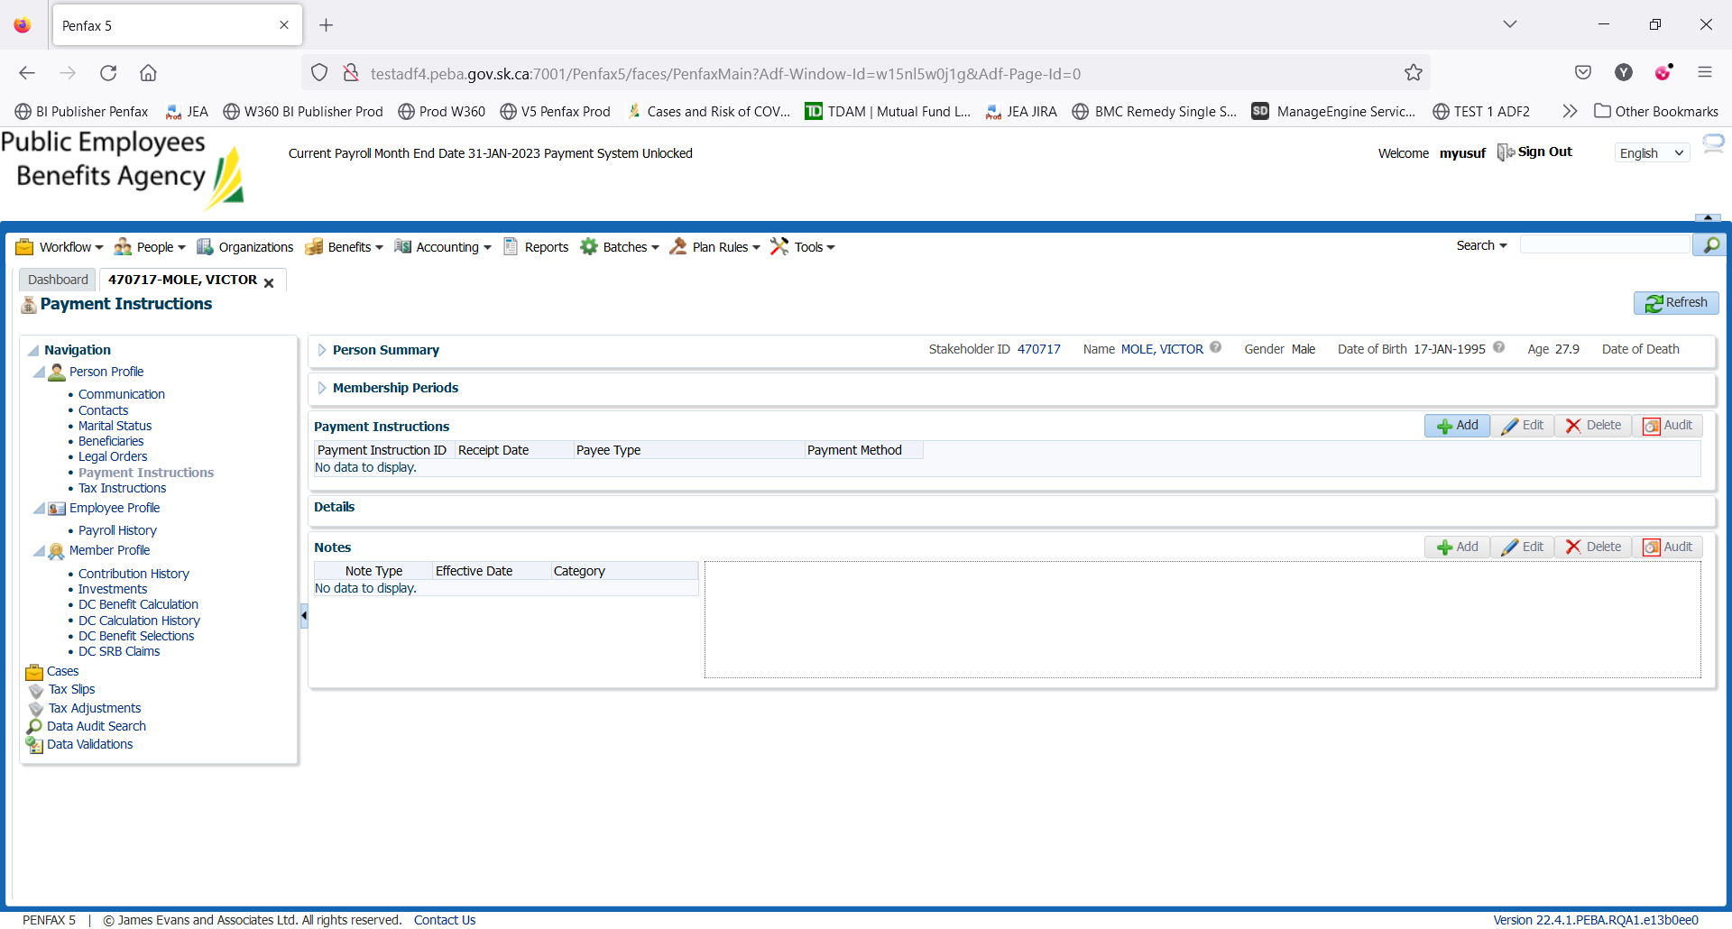

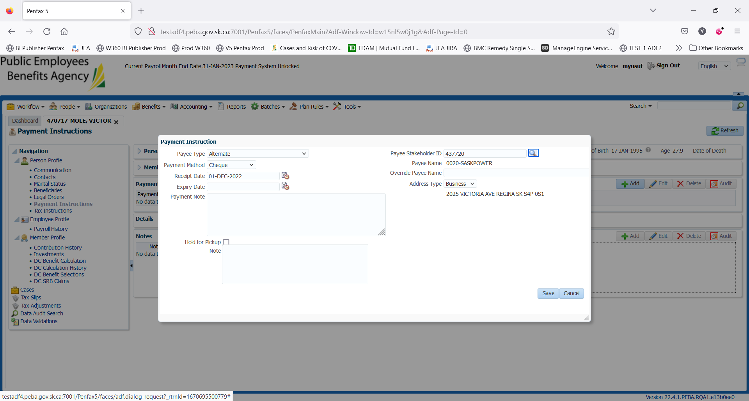

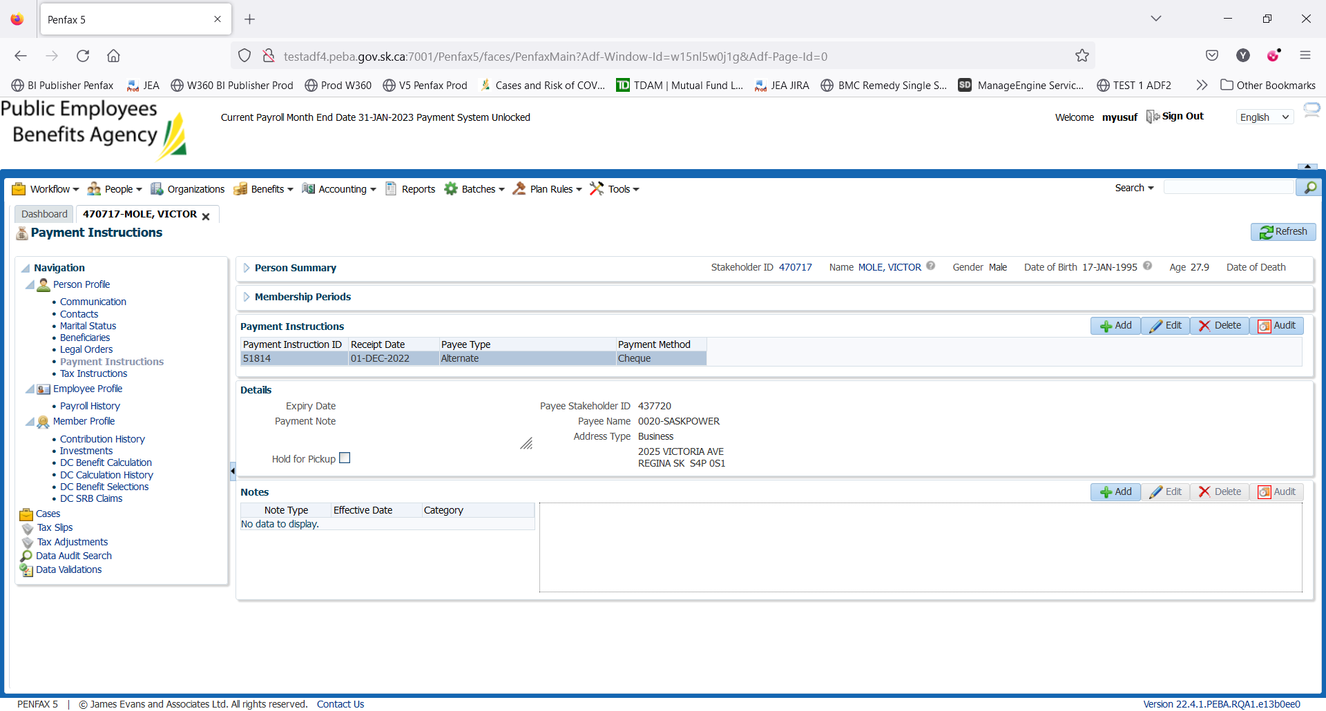

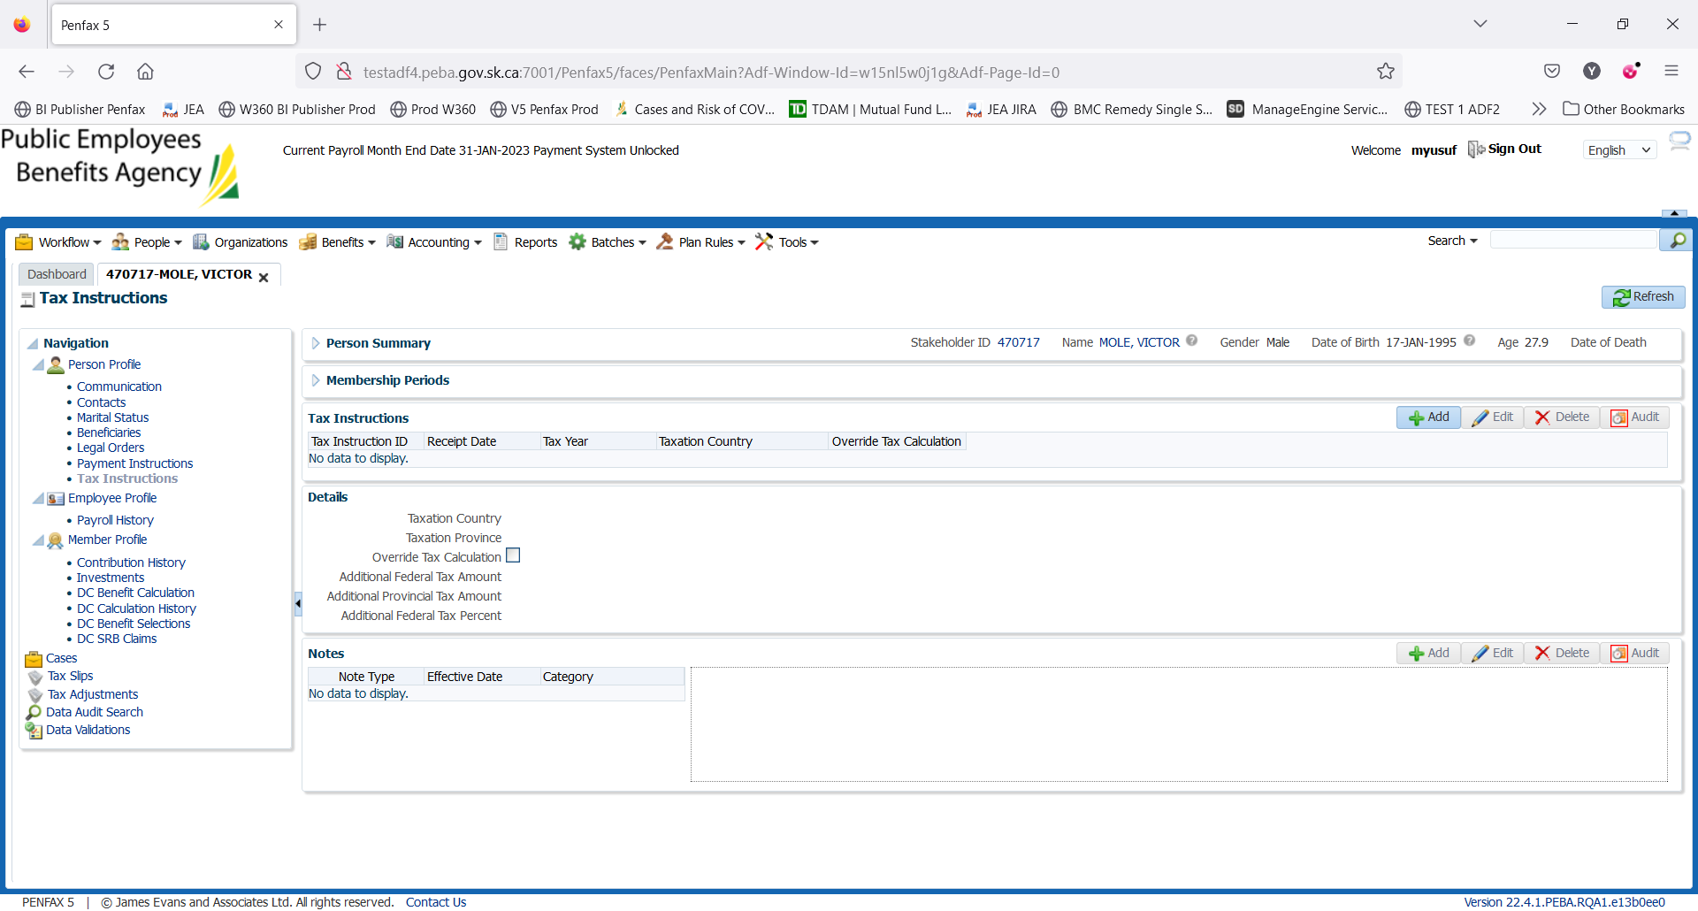

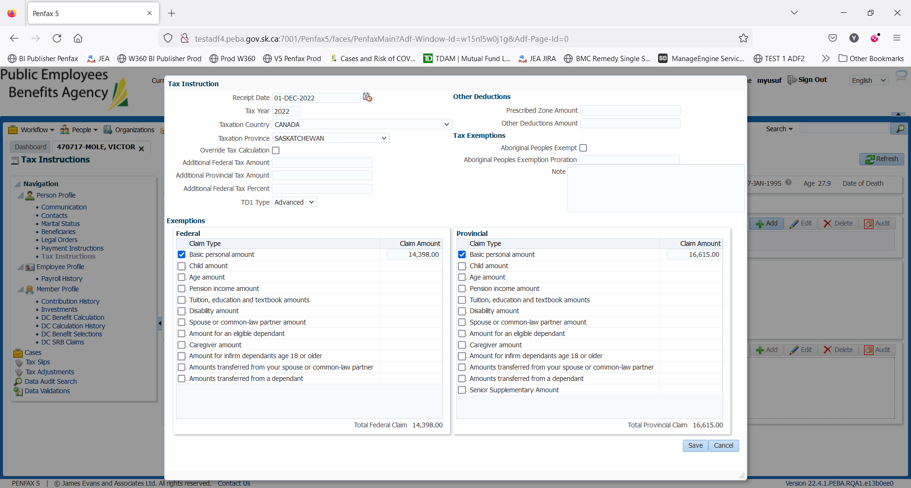

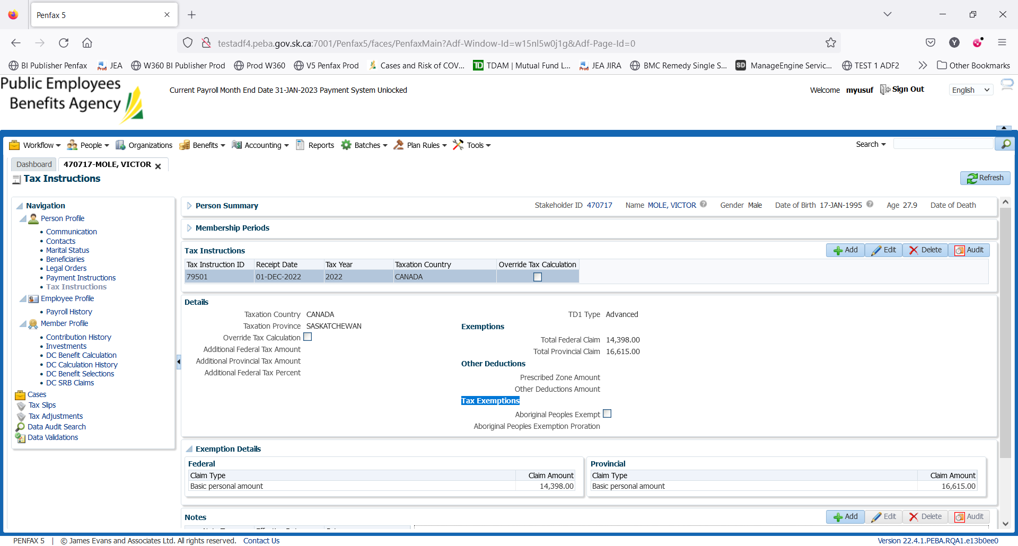

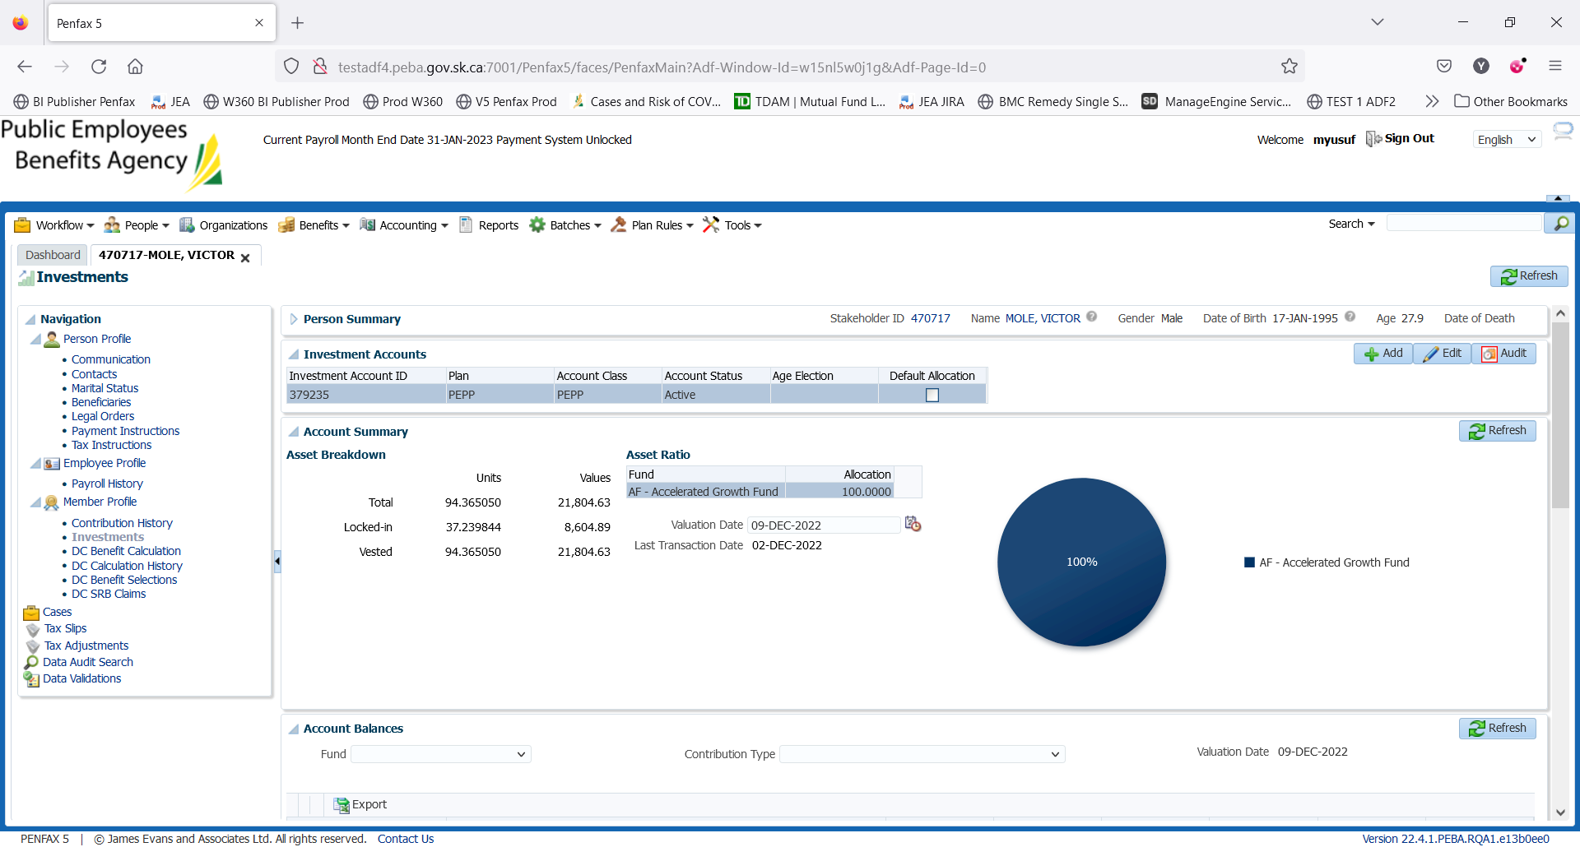

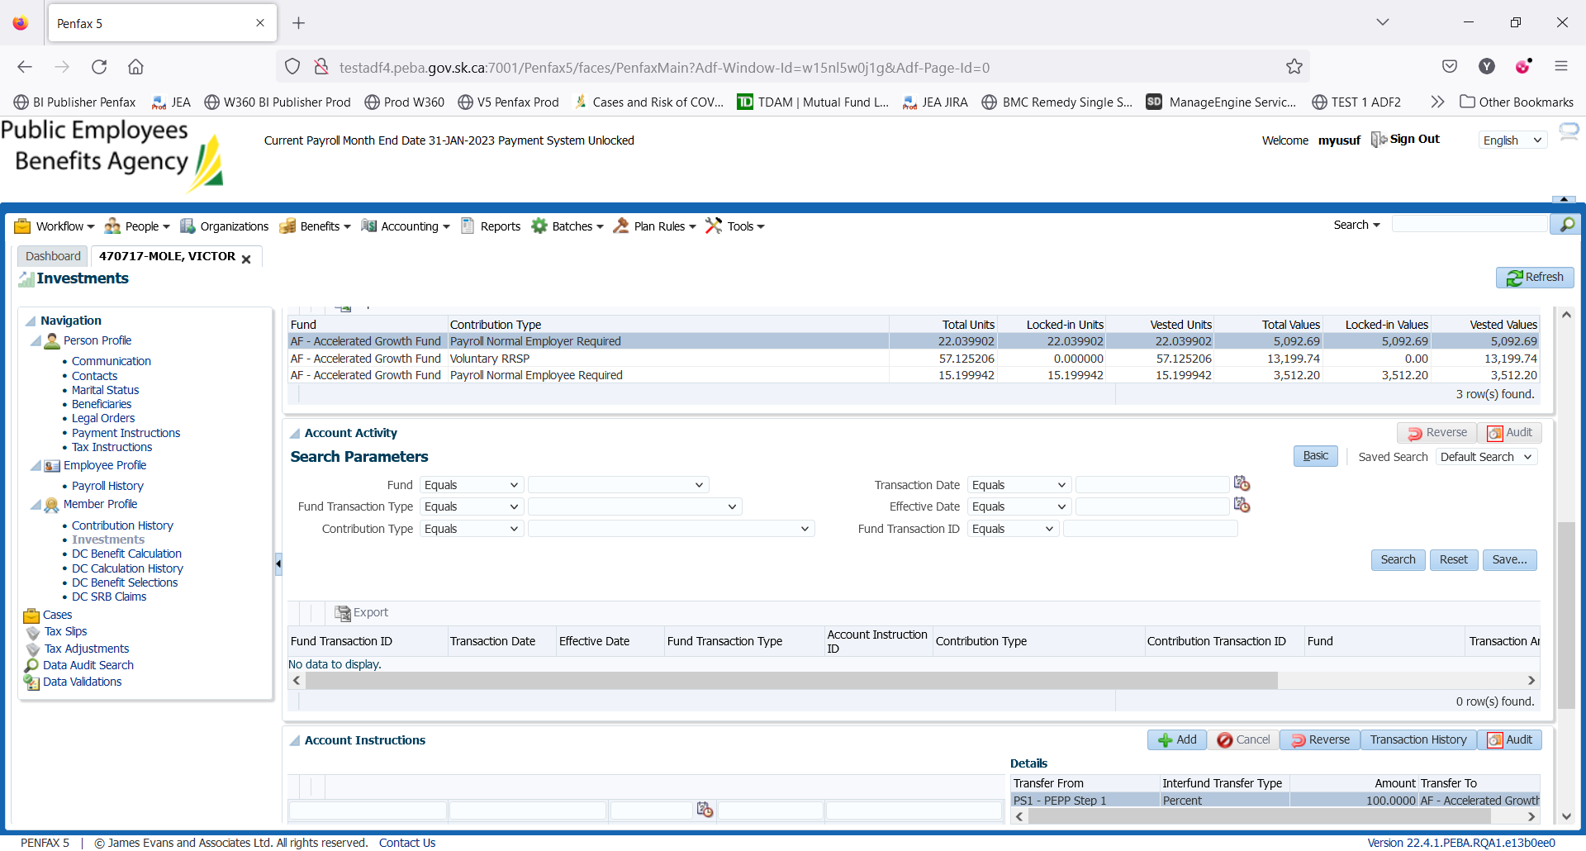

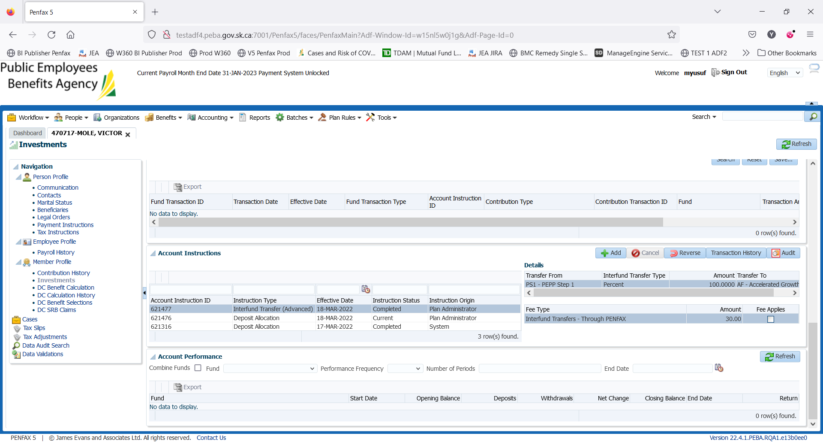

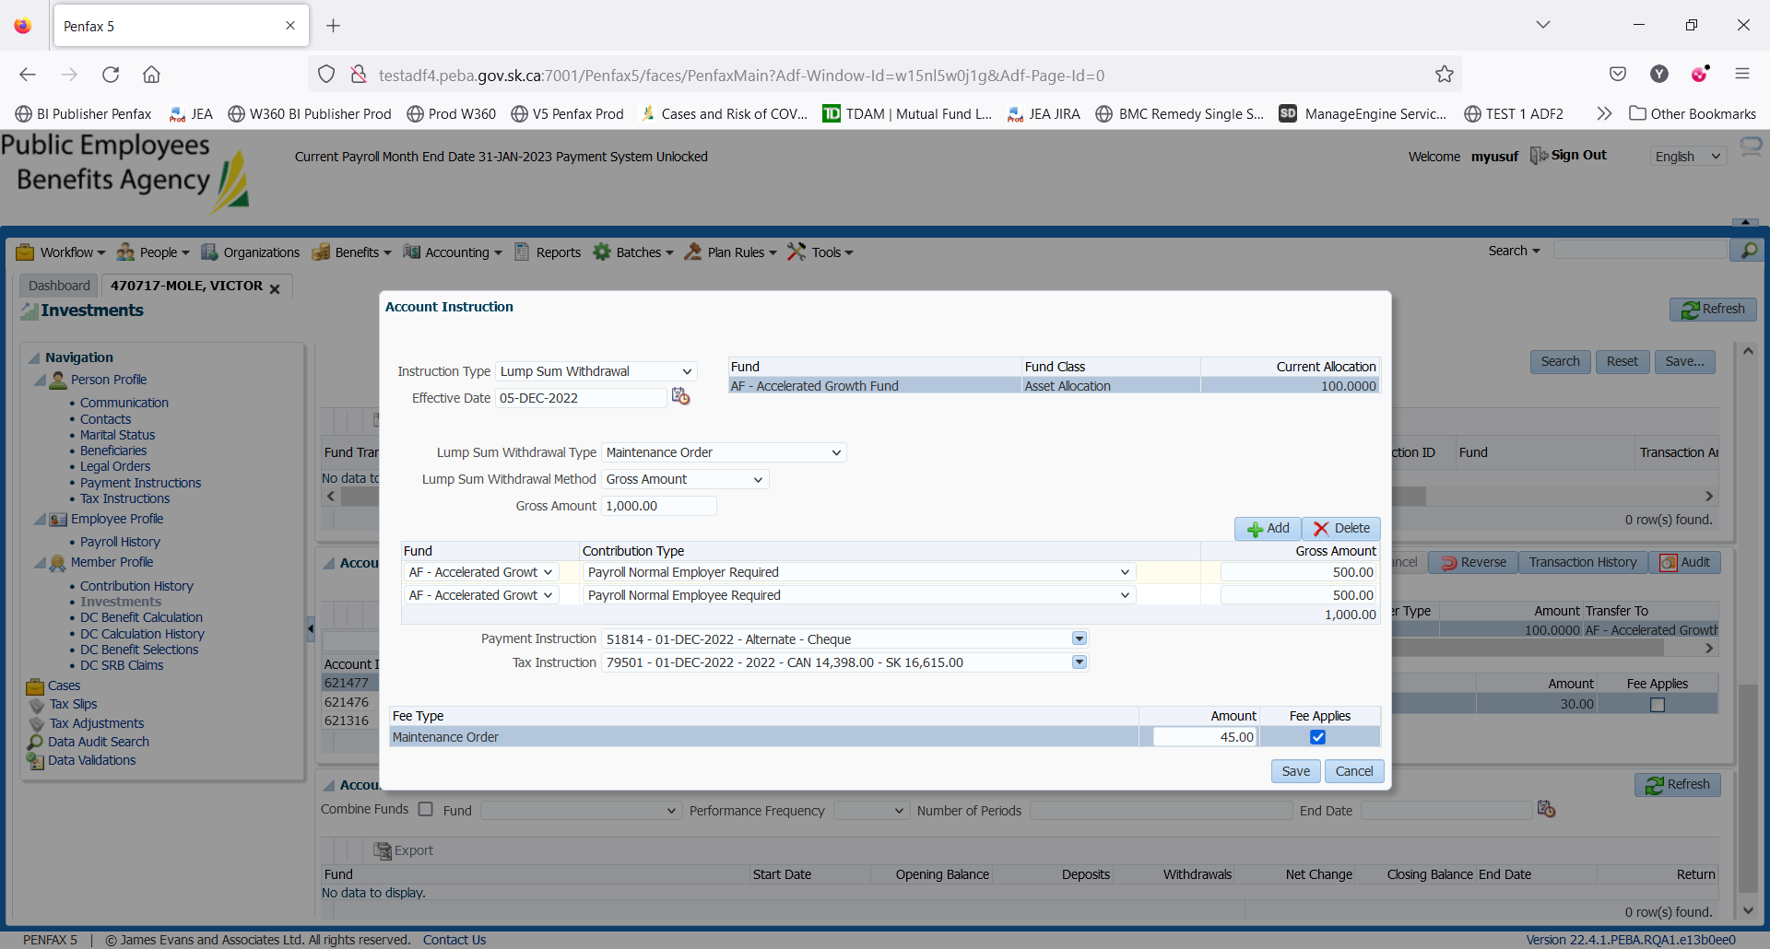

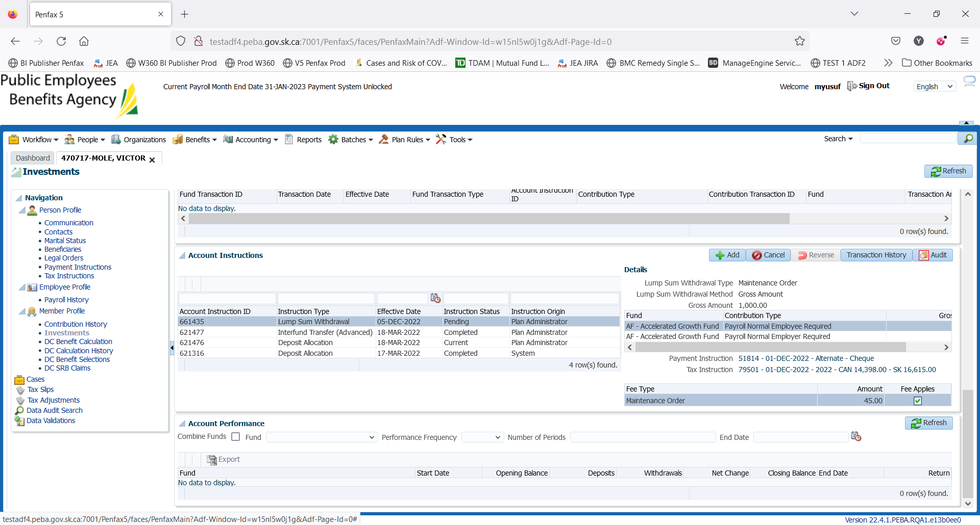

Day2: Wait for the overnight batch

